Contents
Task 2 - Knight’s Tour Problem 2
Background 2
Task Statement 2
Implemented Key Features 2
Comprehensive Description 3
Problem Solution 3
Detailed explanation of the solution 3
Pseudo Code 4
Implementational Code 5
Algorithm analysis – time & space complexity 7
Sample outputs 7
Answers to Task Questions’ 9
Alternative Solutions 9
Key findings and insights 9

Task 2 - Knight’s Tour Problem

Background
- A chess knight moves in an “L” shape: two squares in one direction and then one square perpendicular.
- On an $n×n$ chessboard, a knight’s tour is a sequence of moves that visits every square exactly once (landing on each square, not just passing over it).
- If the first and last squares of the tour are a knight’s move apart, the tour is called closed or re-entrant (otherwise it is open).
- In the context of a closed (re-entrant) knight’s tour, the tour must end on a square that is exactly one knight’s move away from the starting square. This means that if you place a knight on the last square of the tour, it can move directly to the first square in a single legal knight move.
- Warnsdorff’s rule is a heuristic for finding a knight’s tour on a chessboard. It is a greedy algorithm that decides the next move at each step based on the number of onward moves available from each candidate square.
- In graph theory, a Hamiltonian path is a path in a graph that visits every vertex exactly once.
A Hamiltonian circuit (or Hamiltonian cycle) is a Hamiltonian path that starts and ends at the same vertex, forming a cycle.
- greedy algorithm is a problem-solving approach that makes the locally optimal choice at each step, hoping that these local optima will lead to a global optimum solution

Task Statement
- 8×8 board
Is it possible for a knight to visit all 64 squares of a standard chessboard exactly once, ending on a square that is one knight’s move away from the starting square?
Justify your answer.
- General $n×n$ board
For which values of $n$ does a closed knight’s tour exist?
For all $n>8$, is a closed tour always possible? If not, describe the cases where it is impossible and explain why.
- Greedy algorithm
Design a greedy algorithm that determine the minimum number of moves the knight needs to visit all squares exactly once.
- Study of different $n$

Implemented Key Features
- Get input from the user with the n rows or columns of the board
- Get the start square from the user
- Run greedy algorithm to find is there closed Tour
- Display the result and the minimum number of moves the chess knight needs.

Comprehensive Description
The knight’s tour is a classic mathematical and computational puzzle that asks whether a chess knight can visit every square of a given chessboard exactly once, moving according to the standard rules of chess. A knight moves in an “L” shape: two squares in one direction (horizontally or vertically) and then one square perpendicular, or vice versa. The knight does not jump over pieces, but the board is initially empty; only the knight’s movement restrictions matter.
Two types of tours are considered:
- Open tour: The knight visits all squares exactly once, ending on any square different from the starting square. The tour does not need to return to the start.
- Closed tour (re-entrant): The knight visits all squares exactly once and the final square is exactly one knight’s move away from the starting square, so the tour could be repeated indefinitely.
The problem can be modelled as a graph problem:
- Each square of the $n×n$ board is a vertex (node).
- A legal knight move between two squares is an edge.
- An open knight’s tour corresponds to a Hamiltonian path in this graph.
- A closed knight’s tour corresponds to a Hamiltonian circuit (cycle).

Problem Solution

Detailed explanation of the solution
- At each step, from the current square, the knight examines all unvisited squares reachable by a legal knight move. For each such candidate square, it counts how many unvisited squares are reachable from that candidate (its degree in the remaining graph).
The knight then moves to the candidate with the smallest such count.
- Reasoning: Squares with few onward moves are most “constrained” and should be visited early to avoid becoming dead ends later. This local greedy choice almost always leads to a complete tour.
A closed (re-entrant) tour requires the first and last squares to be a knight’s move apart.

- For high possibility creating closed Tour Start from a square with an even degree.
The degree of a square is defined as the number of legal knight moves from that square on an empty board , the number of squares a knight can reach in one move, ignoring whether those squares have been visited. For example, on an 8×8 board, a corner has degree 2 (even), a square one step from a corner has degree 3 (odd), and a central square has degree 8 (even).

Pseudo Code
ALGORITHM
//Finds a closed knight’s tour on an n×n board.
//Input: An integer n ≥ 5 (board dimension)
//Output: An n×n array with visit order, or “No solution”

create board[n][n] initialized to −1 // −1 = unvisited
//lists all 8 possible L-shaped knight jumps
moves ← [(2,1),(1,2),(−1,2),(−2,1),(−2,−1),(−1,−2),(1,−2),(2,−1)]
// Before moving to any square, this checks three things: is (x, y) still inside the board, and has it not been visited yet
function isValid(x, y):
return (0 ≤ x < n) AND (0 ≤ y < n) AND (board[x][y] = −1)

// counts how many moves the knight could make from candidate square to other unvisited squares
function countOnward(x, y):
count ← 0
for each (dx, dy) in moves do
if isValid(x + dx, y + dy): count ← count + 1
return count

// Start from (0, 0) — any position is valid
x ← 0; y ← 0
board[x][y] ← 0

for step ← 1 to n×n − 1 do
minDegree ← ∞
nextX ← −1; nextY ← −1

// Try all possible knight moves
for each (dx, dy) in moves do
nx ← x + dx; ny ← y + dy
if isValid(nx, ny) do
degree ← countOnward(nx, ny)
if degree < minDegree
minDegree ← degree; nextX ← nx; nextY ← ny

// No valid move found — fail
if nextX = −1 return “No solution”

// Advance knight
x ← nextX; y ← nextY
board[x][y] ← step

return board

Implementational Code

Includes & global variables
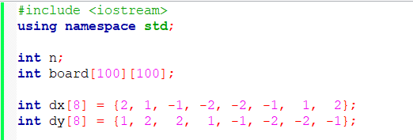

  - n is the board size entered by the user. board[100][100] is declared globally so every function can access it without passing it around. It supports boards up to 100×100.
  - dx and dy are the 8 knight move offsets. Each index i represents one L-shaped jump — dx[i] is the row shift and dy[i] is the column shift

Validation Function

Checks three things at once before allowing a move to (x, y):
- x >= 0 && x < n — row is inside the board
- y >= 0 && y < n — column is inside the board
- board[x][y] == -1 — square has not been visited yet
All three must be true. If anyone fails, the move is rejected.

Degree Calculation
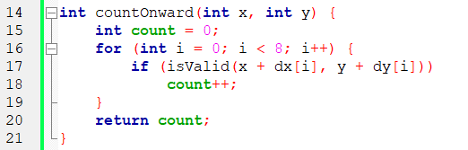

The core of the Algorithm is implemented in the countOnward function. For a given square $\left(x , y\right)$, the function determines the number of unvisited squares reachable by a single knight move. It iterates over all eight possible move offsets and counts those that land within the board boundaries and on an unvisited cell. A small count indicates that the square has few remaining onward movements, making it a candidate that should be visited promptly to avoid becoming isolated and causing the tour to fail.

Greedy Tour Construction
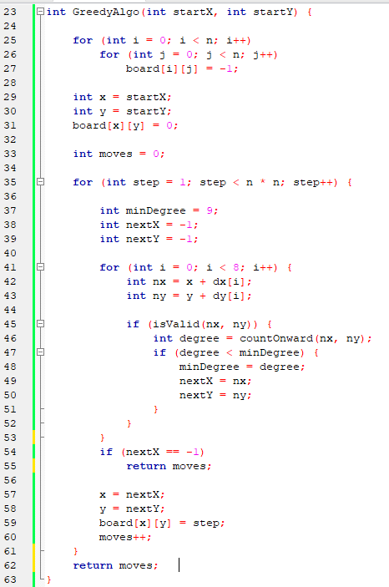

- The initialization phase begins with a double loop that resets every cell of the board to -1, indicating an unvisited state. The knight is then placed at the user-specified starting square, which is marked with 0 to denote the first visited square. A counter, moves, records the number of successfully completed moves.
- The main loop executes exactly $n×n-1$ iterations, as the first square is already occupied. The variable minDegree is initialized to 9 because the maximum possible number of onward moves from any square is 8; thus any valid candidate will immediately yield a smaller value.
- The variables nextX and nextY are set to -1 to serve as a sentinel indicating that no valid move has yet been found.
- Within each iteration, the algorithm examines all eight possible knight jumps from the current position. For each neighbor that lies inside the board and remains unvisited, the function countOnward computes its degree (the number of unvisited squares reachable from that neighbor).
- If this degree is lower than the current minimum, the candidate coordinates are stored in nextX and nextY. After evaluating all eight directions, (nextX, nextY) refers to the most constrained reachable square.
- If nextX remains -1 after the loop, no valid move exists; the knight is stuck, and the function returns the current value of moves (a partial tour). Otherwise, the knight moves to the selected square, records the step number in the board array, and increments moves. Upon completing a full tour, moves will equal $n×n-1$

Algorithm analysis – time & space complexity
- Time: $O(n^{2})$ – each of the $n^{2}$ steps examine at most 8 neighbors and counts their onward moves (each also ≤8 checks).
- Space: $O(n^{2})$ for the visited matrix and tour storage.

Sample outputs
Test Case | Sample Output | Visualizing (AI generated)
1 | 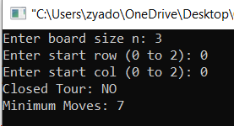 | 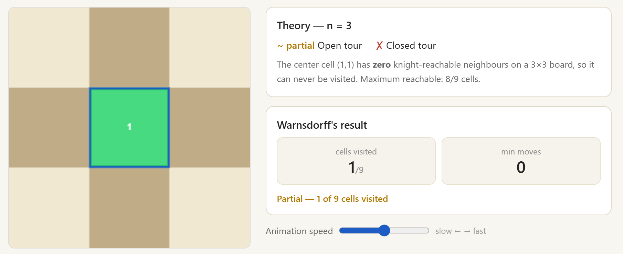
2 | 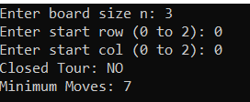 | 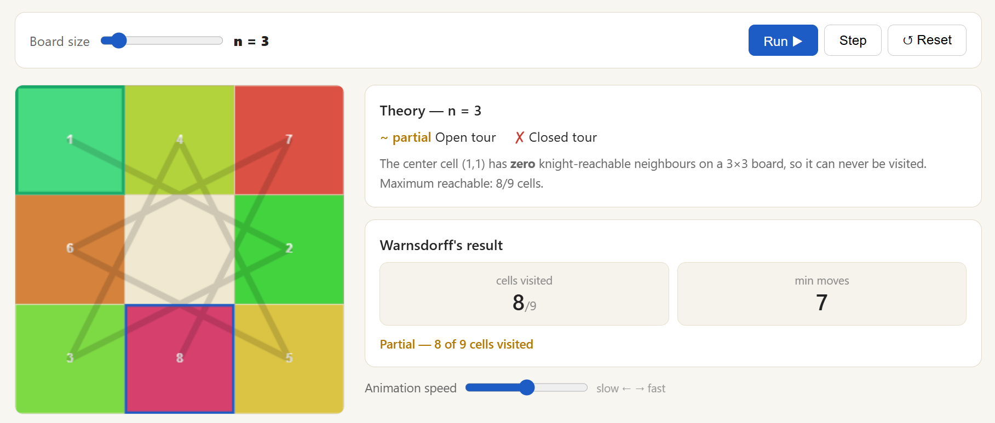
3 | 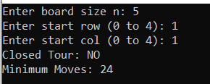 | 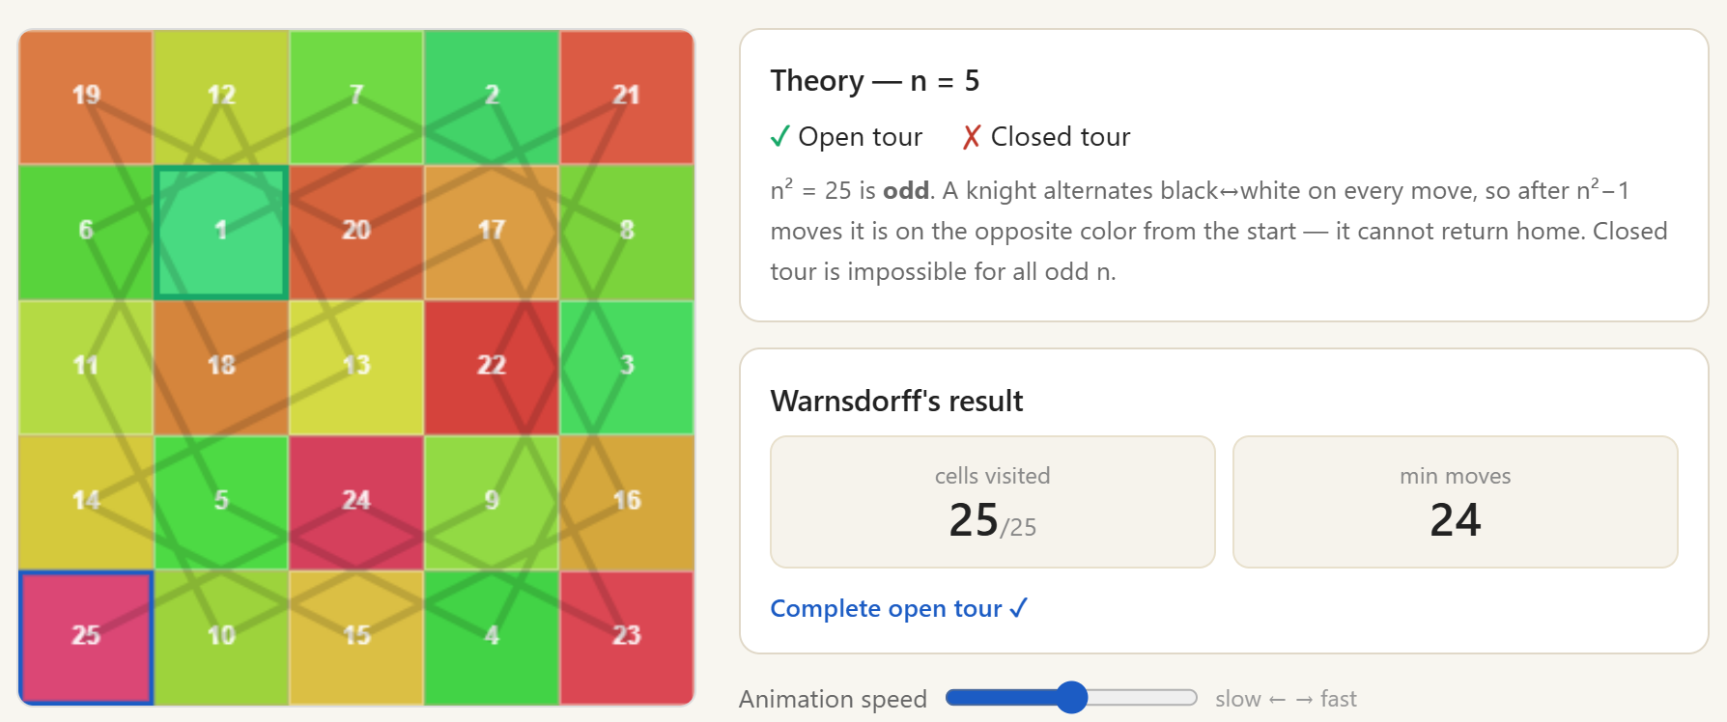
4 | 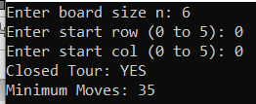 | 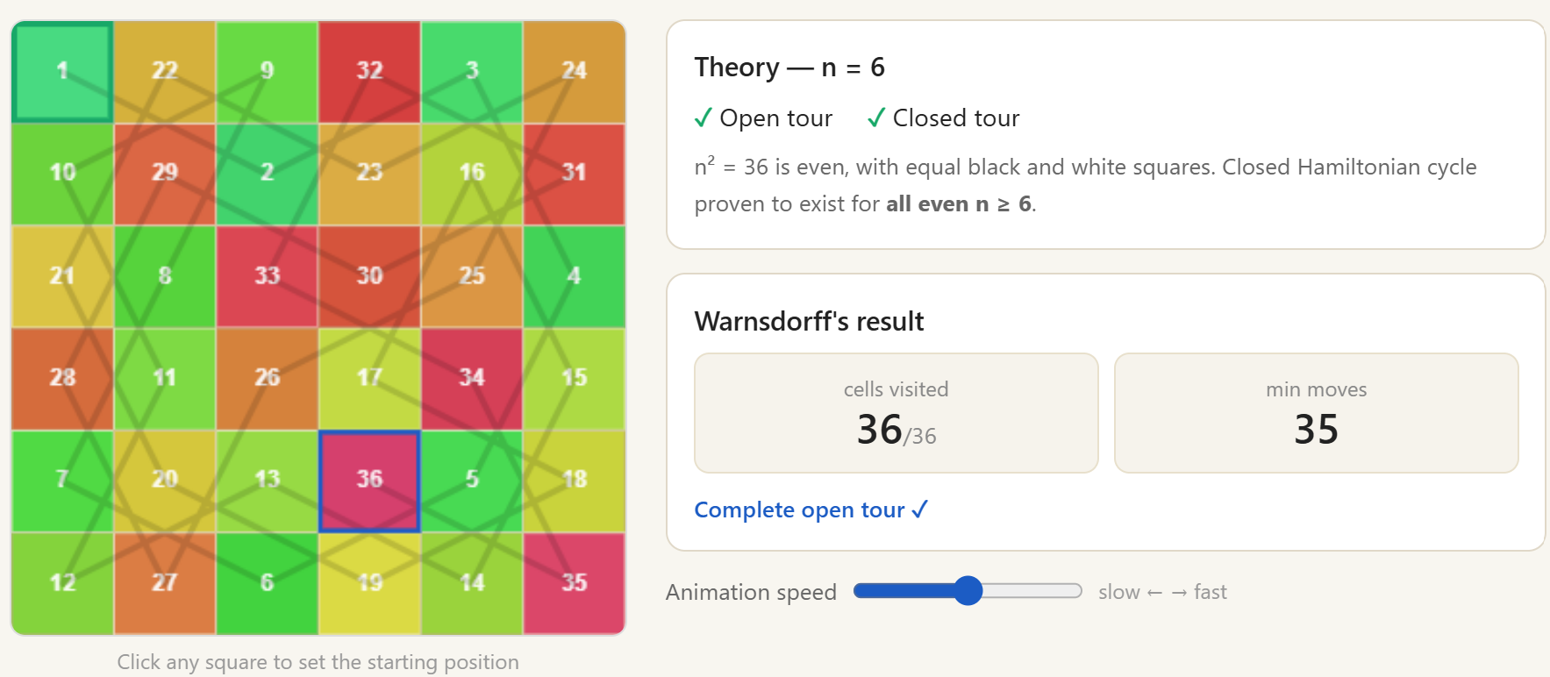
5 | 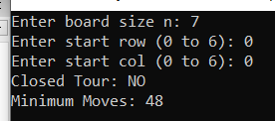 | 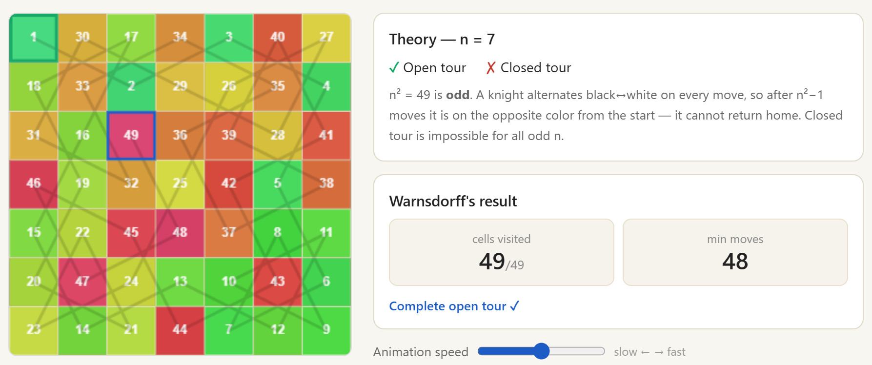
6 | 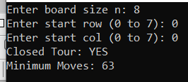 | 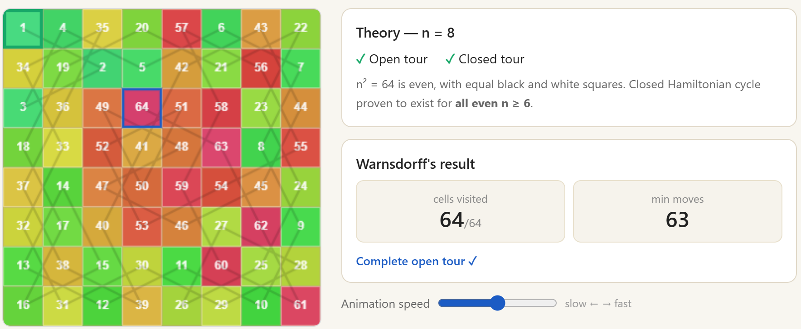

Answers to Task Questions’
1) Yes — a closed knight's tour on 8×8 exists
2) Closed tours exist for all even n ≥ 6. They are provably impossible for all odd n (parity argument) and for n ≤ 4 (small-board arguments). So every n > 8 that is even supports a closed tour, while every odd n > 8 supports only an open tour.
3) Greedy algorithm is designed above
4) Cases for all n:
n | Open tour | Closed tour | Min moves
2 | ✗ | ✗ | —
3 | ✓ | ✗ | 7
4 | ✓ | ✗ | 15
5 | ✓ | ✗ | 24
6 | ✓ | ✓ | 36
7 | ✓ | ✗ | 48
8 | ✓ | ✓ | 64
9 | ✓ | ✗ | 80
10 | ✓ | ✓ | 100
≥5 odd | ✓ | ✗ | n²−1
≥6 even | ✓ | ✓ | n²

Alternative Solutions
Max-Degree Heuristic (MDH)
Selects the node with the maximum onward degree, aiming to maintain high mobility. This delays low-degree nodes, leading to late dead-ends – the opposite of Warnsdorff.
Edge-Avoidance Heuristic (EAH)
Avoids low-degree nodes (edges/corners) as an implicit degree-based strategy. This reduces early trapping but is less precise than explicit degree calculation.
Random Greedy (RG)
Makes a random choice among all valid moves at each step. This avoids deterministic traps but offers no guarantee and is unstable; often used with multiple retries.
Hybrid Greedy (HG – Best Practical)
Combines Warnsdorff as the primary rule with tie-. This improves robustness, reduces failure cases, and is near-optimal in practice.

Key findings and insights
- The knight’s tour can be modelled as a graph traversal problem, specifically that of finding a Hamiltonian path or cycle on the graph induced by the chessboard.
- Closed tours require even n ≥ 6 Odd boards have unequal black/white squares — the knight can never return to its start color, making closed tours mathematically impossible for all odd n.

